**Running Node App with Docker Container connected to other MongoDb container via custom Bridge network**

1. Clone mongodb docker image from docker hub

<https://hub.docker.com/_/mongo>

Command: docker pull mongo

1. Run that mongodb server instance as follow

docker run --name <mongo-container-name> -d mongo:tag

1. Create a bridge network as follow

docker network create <bridge_network_name>

1. Connect (mongodb) container to new bridge network

docker network connect <bridge_network_name> <container name>

At this stage we started mongodb container and create a bridge network and attach that network to our mongodb container.

1. Get the IP address of mongodb container by inspecting <bridge-network> as follow

docker network inspect <bridge-network-name>

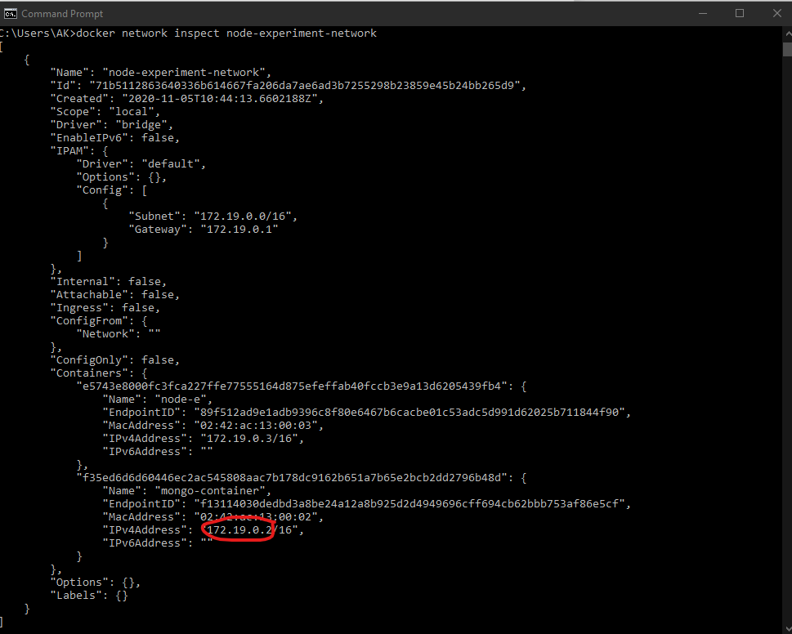

1. Note down this IP of mongodb container this will be used to connect other container to this container
2. Edit Nodejs app use the above IP of mongodb container to connect to mongodb in node app

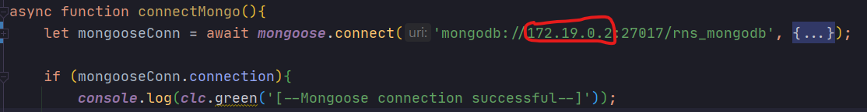

1. Build (Node App) docker image by running DockerFile

Command docker build -t <image_name> . // Don’t forget the last dot

1. Run the container image as follow

docker run -p 3001:3000 --name <any_name> -d <image_name>:tag

3001:3000 mean binding 3000 port of container to 3001 port of host (localhost)

1. Connect (Node App) container to same bridge network created above

docker network connect <bridge_network_name> <container name>

**Thatsall**. Verify that Node app connected to mongodb container by inspecting logs

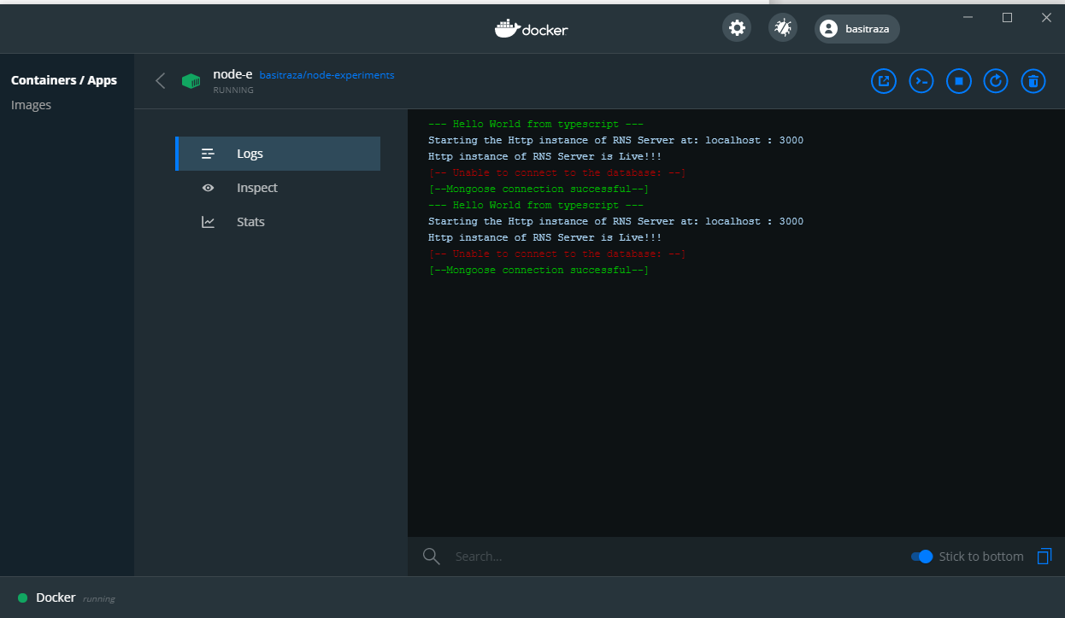

Go to localhost:3001 and Node App will be ready

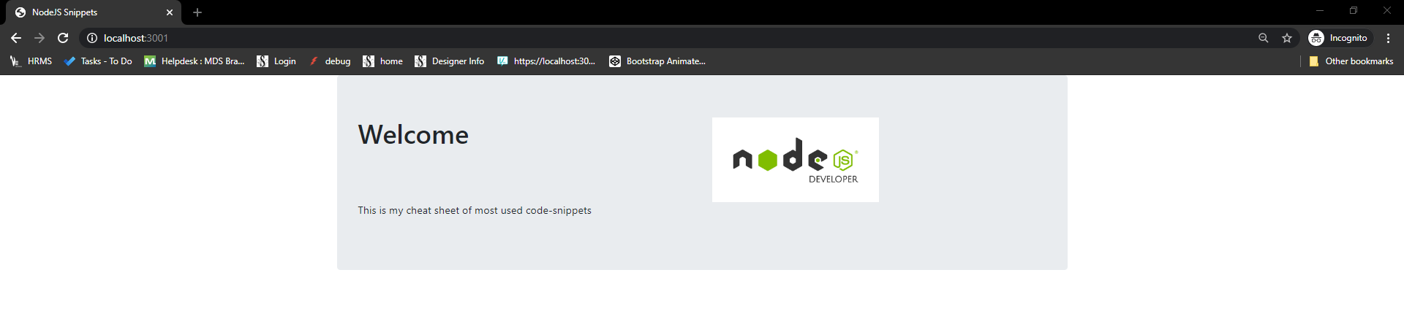

Author: Basit Raza